Laxmi Charitable Trust’s
Sheth L.U.J College of Arts s Sir M.V. College of Science and Commerce
Department of Information Technology (B.Sc.I.T Semester V)
MERN STACK

Practical – V

Roll No.: T022 | Name: pratik mishra
Class: TYIT | Batch:1
Date of Assignment: 12-08-26 | Date/Time of Submission: 12-08-26
- React Routing and Data Handling
  - Install and configure React Router in the React application. Code :
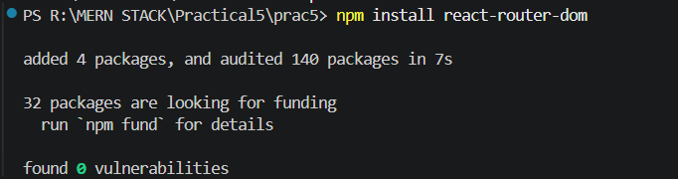
  - Create multiple pages and implement navigation between them. Code :
Home.jsx function Home(){
return (
<div>
<h1>Home page</h1>
<p>Welcome to our React Application.</p>
</div>
);
}
export default Home;

About.jsx function About(){
return (
<div>
<h1>About Page</h1>
<p>This Page contains information about our application.</p>
</div>
)
}
export default About; Contact.jsx
function Contact(){ return (
<div>
<h1>Contact Page</h1>
<p>Mobile number : 932866990</p>
<p>Gmail : pratik mishra@gmail.com</p>
</div>
);
}
export default Contact;

App.jsx
import {BrowserRouter , Routes, Route, Link } from "react-router-dom"; import Home from './Pages/Home';
import About from './Pages/About'; import Contact from './Pages/Contact';

function App() { return (
<BrowserRouter>
<h1>My React application</h1>
<nav>
<Link to="/">Home</Link>
<br/>
<Link to="/About">About</Link>
<br/>
<Link to="/Contact">Contact</Link>
<br/>
</nav>
<hr/>
<Routes>
<Route path="/" element={<Home/>}/>
<Route path="/About" element={<About/>}/>
<Route path="/Contact" element={<Contact/>}/>
</Routes>
</BrowserRouter>
);
}
export default App; Output:
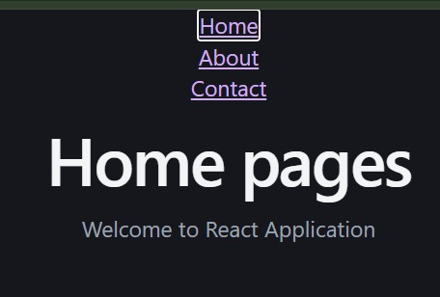


  - Use Link and Routes to move between pages. Code :
Dashboard.jsx function Dashboard(){
return (
<div>
<h1>Placement Dashboard</h1>
<p>This is the dashboard page of our application.</p>
<hr/>
<h2>Placement Details</h2>
<p>Total Companies: 10</p>
<p>Placed Students: 50</p>
<p>Highest Package: 16 LPA</p>
</div>
);
}
export default Dashboard;
Profile.jsx function Profile(){
return (
<div>
<h1>Profile Page</h1>
<p>Name:Prajapati raj</p>
<p>Email:pratik mishra@gmail.com</p>
<p>Phone: 1234567890</p>
<p>Skill: JavaScript,MERN</p>
<p>CGP : 9.9</p>
</div>
);
}
export default Profile;
Jobs.jsx
function Jobs() { return (
<div>
<h1>Jobs Opportunities</h1>
<p>We have many job opportunities available for students.</p>
<hr/>
<h2>Job Listings</h2>
<ul>
<li>Software Engineer at XYZ Company</li>
<li>Frontend Developer at ABC Company</li>
<li>Backend Developer at DEF Company</li>
<li>Full Stack Developer at GHI Company</li>
</ul>
<h2>Apply for a Job</h2>
<p>Interested in any of the above positions? Fill out the application form below.</p>
</div>
)
}

export default Jobs;
Statistics.jsx function Statistics() {
return (
<div>
<h1>Placement Statistics Page</h1>
<p>This is the statistics page of our application.</p>
<hr/>
<h2>Statistics Details</h2>
<p>Total Students: 100</p>
<p>Placed Students: 50</p>
<p>Unplaced Students: 50</p>
<p>Average Package: 8 LPA</p>
</div>
)
}
export default Statistics; App.jsx
import {BrowserRouter , Routes, Route, Link } from "react-router-dom"; import Dashboard from './Pages/Dashboard';
import Profile from './Pages/Profile'; import Jobs from './Pages/Jobs';
import Statistics from './Pages/Statistics';
function App() { return (
<BrowserRouter>
<h1>M.V.L.U Placement Portal</h1>
<nav>
<Link to="/">Dashboard</Link>
<br/>
<Link to="/Profile">Profile</Link>
<br/>
<Link to="/Jobs">Jobs</Link>
<br/>
<Link to="/Statistics">Statistics</Link>
<br/>
</nav>
<hr/>
<Routes>
<Route path="/" element={<Dashboard/>}/>
<Route path="/Profile" element={<Profile/>}/>
<Route path="/Jobs" element={<Jobs/>}/>
<Route path="/Statistics" element={<Statistics/>}/>
</Routes>
</BrowserRouter>
);
}
export default App; Output:

